How to Complete AHIP Medicare testing

The AHIP test costs $175. If you access the course by going through most carriers’ websites (Aetna, Humana, UnitedHealthcare, etc.), you will be charged the discounted price of $125.

Log in to the carrier’s website and choose AHIP, or log into AHIP directly at www.ahipmedicaretraining.com.

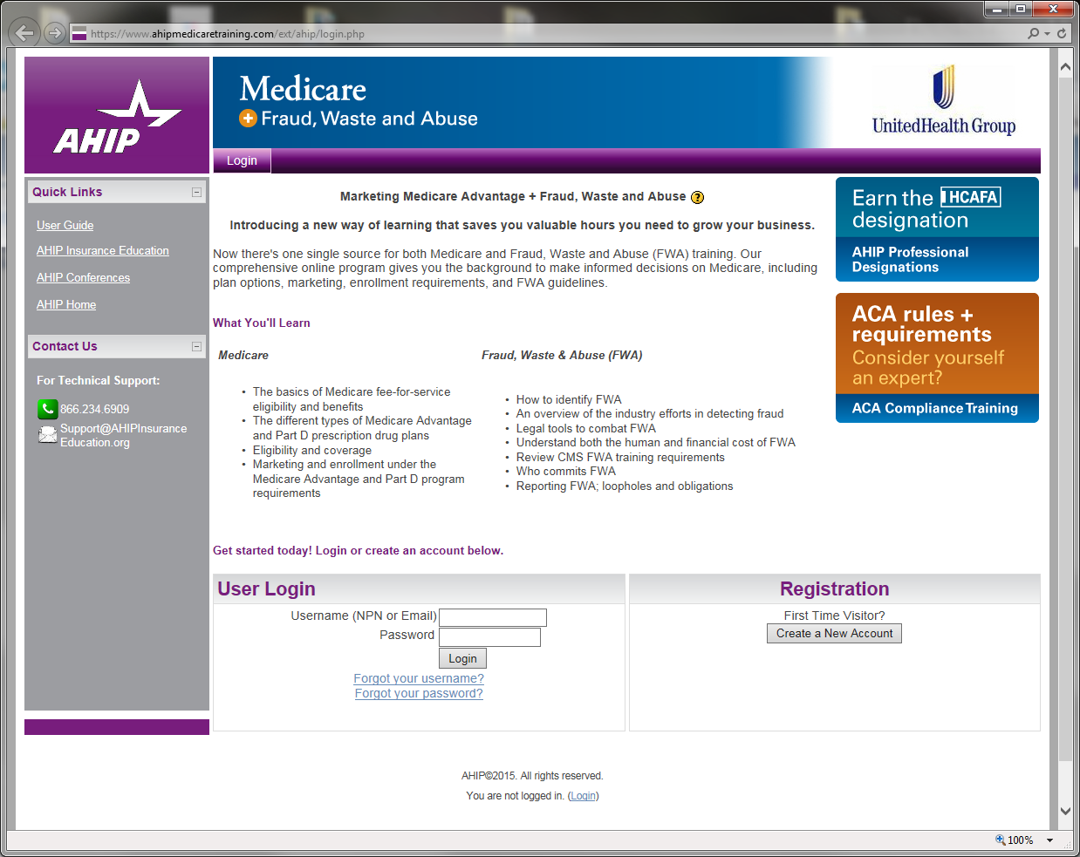
New Users

Returning Users

If you are a New User, Register to create an account. If you are a Returning User, log in with your AHIP credentials, or click on the links for Forgot Password or Forgot Username.

New users will be asked to provide name, DOB, and NPR number, and you will create a password. You will then confirm your purchase of the test.
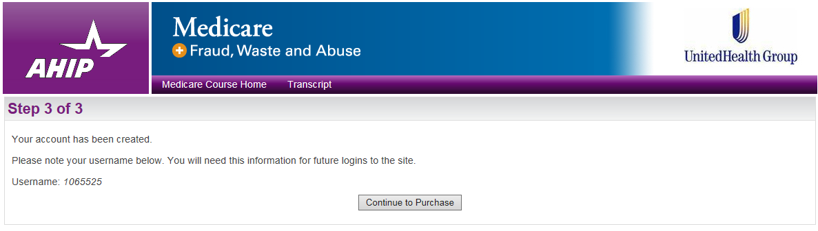
AHIP consistes of 5 modules and tests. Users who have previously completed AHIP will only be required to complete 2 Modules and tests.

Users will also need to compete the AHIP Fraud, Waste and Abuse and Compliance training. Most carriers will ask you to attest that you have completed the FWA training, either through CMS or AHIP.

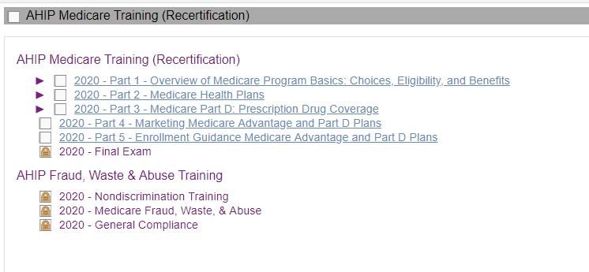

The modules are downloadable. PLEASE download a copy of the modules so that you can refer to it during the testing process.

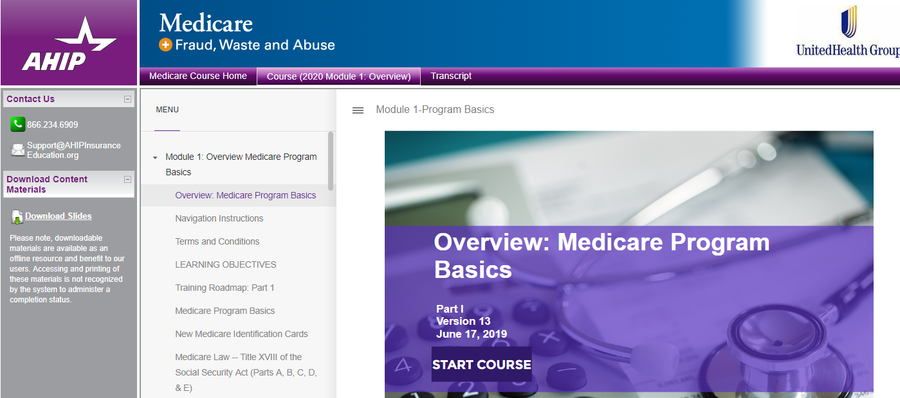

Technical questions regarding AHIP’s test or website should be directed to AHIP at 866-234-6909 or Support@AHIPInsuranceEduation.org.

Complete all courses, including the Fraud, Waste, and Abuse training.

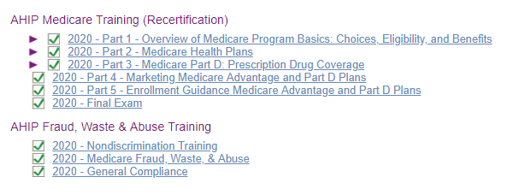

Once your testing is complete, you will be able to print your certificate.

